DEALS TO BEVERLY HILLS

The Los Angeles city of Beverly Hills is home to so many actors and celebrities the 90210 zip code has become shorthand for a glamourous California lifestyle. Book a trip to Beverly Hills via Los Angeles International Airport on Virgin America. Live it up at 35,000 feet with WiFi, on-demand entertainment, and more on every flight.

(MARKET IMAGE HERE)

Find Deals From These Cities

INSERT FARE GRID FROM / TO Version (if available!)

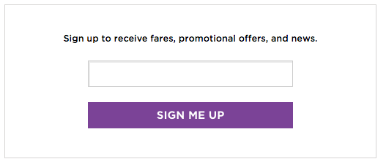   
Top Things To Do in Beverly Hills

If you’re wondering what to see in Beverly Hills outside of the high-end shopping and five-star accommodations it’s known for, you’re in the right place! There are plenty of fab things to do in Beverly Hills no matter what your interests are. We’ve listed a few favorites below.

* Admire the public art sculptures in Beverly Gardens Park. While there, take a jog or leisurely stroll along the pedestrian trail and be sure to stop and smell the roses at the Rose Garden.
* Get your sugar fix. Whether you stop at the world's first 24-hour cupcake ATM at Sprinkles Cupcakes, get some chocolate at Edelweiss Chocolates (still processing their chocolates by hand, this is one of the oldest confectionaries in America), or sample some gourmet candy at Sugarfina’s tasting bar, you’ll be in dessert heaven.
* In the summertime, head to Beverly Canon Gardens to listen to some great music at the Concerts on Canon.

Travel Tips and Resources

[Must-Dos in Beverly Hills](http://lovebeverlyhills.com/things-to-do)

[Beverly Hills Hotels](http://www.tripadvisor.com/Hotels-g32070-Beverly_Hills_California-Hotels.html)

[Beverly Hills Restaurants](http://www.laweekly.com/restaurants/20-best-restaurants-in-los-angeles-6164505)

[Beverly Hills Shopping Guidehttp://lovebeverlyhills.com/shopping](http://lovebeverlyhills.com/shopping)

[Beverly Hills Nightlife and Entertainmenthttp://lovebeverlyhills.com/articles/view/beverly-hills-bars-and-lounges](http://lovebeverlyhills.com/articles/view/beverly-hills-bars-and-lounges)

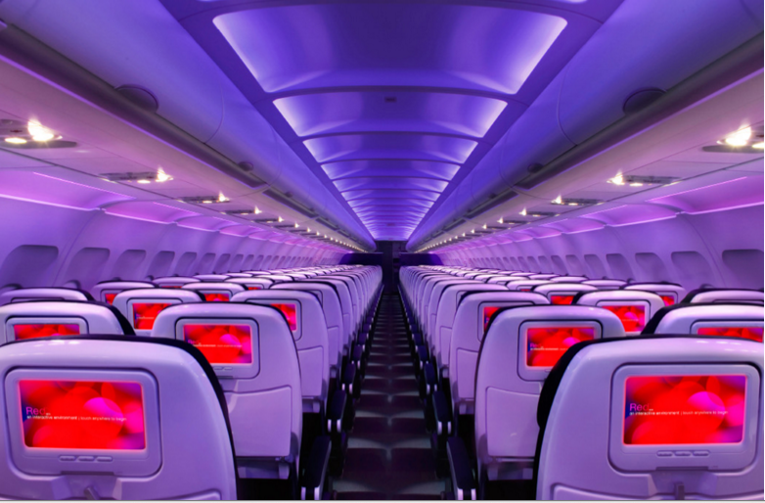

Main Cabin Main Cabin Select First Class

(add links to Cabin Class Pages)

Ready. Set. Fly.

Book your Mood-lit Ride to Beverly Hills.

Planning a trip to Beverly Hills? When you fly into Los Angeles International, you’re only a 30-minute car ride away from this chic location. Book your flight to L.A. with Virgin America and you can start relaxing as soon as you board your flight. Our first-class flying experience provides the ultimate in convenience and entertainment - everything you need to have the flight of your dreams before reaching your dream destination.

Take a Virtual Tour

Add Terms & Conditions